Acoustic Side Channel Attacks:
Keystroke Classification from Microphone Recordings
Student Name: Domantas Prialgauskas
Student ID: C00285607
Program Title: Cybercrime & IT Security
Program Code: CW_KCCYB_B
Project Supervisor: Richard Butler

Table of Contents:
- Introduction & Background
- Dataset Collection
  - Recording Setup
  - Data Design and Storage
- Signal Processing and Keystroke Segmentation
  - Preprocessing
  - Peak Detection and Window Extraction
  - Segmentation Quality Controls
  - Sentence Mode Tuning
- Feature Extraction
  - MFCC Pipeline
  - Rationale
  - Distribution Shift
- Machine Learning Model
  - Model of Choice
  - Training Pipeline
  - Leakage Control
- Offline Evaluation
  - Metrics
  - Experimental Protocol
  - Results
  - Interpretation
- Live System and Demo
  - Real-Time Pipeline
  - Key Failures
  - Improvements Implemented
  - Adaptive Live Training
- Word and Sentence Decoding
  - Word and Sentence Decoding
  - Confusion-Aware Substitutions
  - Sentence Mode and Spacebar Integration
- GUI Implementation
- Security Discussion
  - Threat Model and Realism
  - Sensitivity Analysis
  - Defenses
- Limitations
- Conclusion
- References

- Introduction & Background:

Acoustic side channel attacks exploit information leakage through sound produced during ordinary interaction with a computer system [22] . Unlike software vulnerabilities, side channel leakage refers to the leakage produced by the physical system and environment. A single user’s actions on a system can leave measurable traces in audio, timing or electromagnetic emissions. Keyboards are a particularly relevant target because each press produces a short transient with a repeatable spectral structure, making it plausible that typed input could be inferred from microphone recordings under suitable conditions. [1] [4]

Prior research has determined that keyboard acoustics can leak significant information about user input and that performance of such an acoustic side channel attack classification system heavily depends on microphone placement, room acoustics, keyboard type and user typing style.[1] [4]

The chosen approach will be done with a single mechanical keyboard, the system in place follows a lightweight, interpretable pipeline rather than a heavy deep learning solution. If you can source the same keyboard of the user you are interested in conducting such an attack for, then the pipeline is repeatable and relatively effective at classification. This is efficient in the sense that in an office or library environment, the laptops and machines in use are commonly standardized, therefore if you can source the keyboard and record datasets of each keystroke for a standardized environment’s keyboard, then this attack can be replicated on a larger scale. The proof of concept displayed will show that if you have a known keyboard, you can follow the steps of this report and replicate the attack yourself.

The system built first segments continuous audio into individual keystroke windows using RMS peak energy detection, this chosen lightweight approach for segmentation unfortunately makes the model unable to perform well under immense background noise, therefore, quiet environments are most favorable conditions for the attack, without any specialized hardware or LLM signal preprocessing, background noise is not an issue I was able to overcome efficiently and not one that was majorly pursued due to the fact that it goes against my claim of that this attack is reproducible using open source software and no specialized gear. Under time constraints, I prioritized controlled conditions, robust performance under heavy noise is future work.

Once a keystroke window is extracted, then the Mel-Frequency Cepstral Coefficient features are extracted [2] [6] from said individual keystroke. MFCCs are widely used in speech recognition softwares and audio analysis softwares as they efficiently represent spectral envelopes and provide a compact representation well suited to short transient events such as keystrokes. Those features are then fed to an SVM model [25] which supports the training and classification aspect of the system.
The major practical challenge is bridging the gap between immensely high offline accuracy of the model compared to live demonstration keystroke data. Offline evaluation is made robust by grouping samples by recording session and ensuring those samples are held out together [26] , preventing overly optimistic accuracy due to near duplicate train and test samples. In live settings, however, segmentation and window alignment become the dominant failure mode, even a strong offline classifier can collapse if extraction windows are slightly misaligned or contain non-keystroke transients. For those reasons, the project focusses heavily on detection threshold, debounce behavior and window centering. The project also introduces word level decoding and sentence decoding methods that can recover plausible text from noisy per letter predictions.

Finally, the project treats security relevance and mitigation as first-class outcomes. The goal is not only to show that keystrokes can be inferred acoustically under controlled conditions but also to identify the environmental and system factors that make such interference easier or harder. This includes microphone placement sensitivity, background noise and the practical realism of audio capture [24] [28] .

- Dataset Collection

  - Recording Setup
Dataset collection was designed to support both a defensible offline evaluation as well as a practical live demonstration. Recordings were captured using a single consumer grade USB microphone at 48000hz with the microphone held at a fixed position roughly 15cm above the keyboard [28] . To minimize uncontrolled variability, recordings were performed in a quiet environment, on a consistent surface, and the microphone placement remained constant across recording sessions. This controlled setup reflects prior findings that acoustic keystroke interference is highly sensitive to microphone placement, room acoustics and keyboard characteristics [1] [4] [28] .
  - Data Design and Storage
For the offline dataset, each key (A-Z) was recorded across multiple sessions. In each session the target key was pressed repeatedly, approximately 20 presses per recording, of which there were 100 recordings for each letter providing a database of 52,000 individual keystrokes. Recordings were organized using a structured directory format of datasets/A/A01.wav ->A100.wav for each letter in the alphabet, allowing straightforward data ingestion and traceability. This design supports later evaluation under realistic constraints, by enabling session-aware splitting, ensuring that samples derived from a single recording session can be held out together to prevent leakage between training and test sets.
To support the live demonstration, a separate live-current dataset was collected using the same capture and segmentation pipeline. Instead of storing only long session recordings, each detected keystroke was saved as an individual fixed-length waveform window under datasets_live_current/A/keystrokes/ with filenames encoding the originating session identifier. This ensured that live data closely matched the operational distribution encountered during the demo and enabled controlled adaptive updates such as adding corrected samples to the live-current database without modifying the offline evaluation dataset. This database, built for live demo purposes, contains roughly 90 individual keystrokes per letter and includes the spacebar which all in all provides us with about 2400 or so individual keystrokes that are being used for training and classification of real time demonstrations.

As the system evolved toward word and sentence level decoding, the spacebar was introduced and collected to track the breaks in between words in the sentence decoding mode. Since the spacebar is the largest key on the keyboard, it produces a unique acoustic sound and is very easy to identify for the model, thankfully making the sentence typing mode much more effective. Quality assurance purposes were performed throughout collection and segmentation, including monitoring extraction rates relative to expected keystroke and spot-checking audio windows to confirm that isolated keystrokes were correctly captured. Further quality assurances can be taken by analyzing each keystroke directly through visualizations.

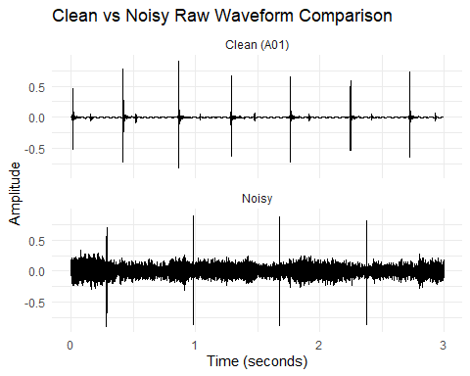

Shown above, is an example of two samples of which one is recorded in a clean and quiet environment compared to a noisy sample, in which case a visualization such as this one created in R Studio using tuner [12] and readWave [13] . Directly comparing side by side the noisy and clean samples provides a clear view of how important diagnostics are at this level of data, we must be able to extract a clean keystroke window in order to have usable data for the machine learning model to learn from, this includes not only the peak on the event but also the small riffles before and after the event, even in the noisy sample we can see that we always find the peak of the keystroke, however, in this project it is essential to be able to capture the entire keystroke window, not just the peak sound, therefore we can easily diagnose the noisy sample and note this would significantly degrade detection reliability.
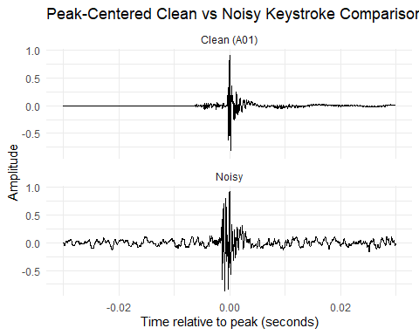
Another visualization created in R Studio using tuner [12] , readWave [13] showing peak centered view up close to the intricacy of a clean versus noisy sample. Comparing both noisy and clean keystroke events and analyzing this data shows that in the example of the noisy sample, it would be virtually impossible to extract the perfect window for the noisy sample because of the noise in the sample corrupting the before, during and after of the event itself. This has diagnostic value again, because taking a deeper look at my raw recordings like this, I can immediately note that the noisy sample is not one that can be sent for machine learning, because the entire key stroke window is necessary for efficient machine learning, not only the peak of the event, the project direction was to focus on and prioritize robustness in a quieter environment.

- Signal Processing and Keystroke Segmentation
3.1 Preprocessing
To prepare recordings for keystroke detection [1] , the signal is first preprocessed to emphasize the frequency content most associated with keystroke transients. A bandpass filter is applied (100-8000hz) to reduce low-frequency rumbles such as desk vibration and handling noise and suppress very high frequency components that are less informative for the keystroke event. This filtering step improves the stability of detection by concentrating energy is a consistent band where key impacts and mechanical resources are prominent, consistent with prior work highlighting the importance of recording conditions and signal characteristics in acoustic keyboard inference [4] [28] .
Following filtering, a short energy representation is computed using the Root Mean Square envelope. RMS is calculated over fixed frames of 20ms with a hop of 10ms, creating an energy trace that tracks transient activity while remaining insensitive to waveform polarity. The RMS series is additionally smoothed using a moving average to reduce fluctuations that can cause false detections. Spectrogram-based inspection was used during development to validate transient visibility and timing in clean versus noisy recordings [5] .
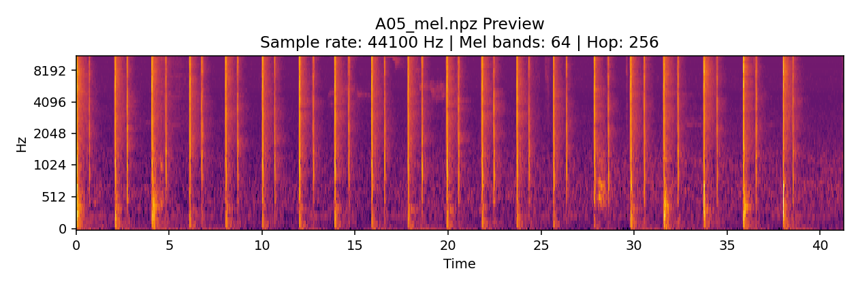
3.2 Peak Detection and Window Extraction
Candidate keystroke events are detected as peaks in the smoothed RMS envelope as discussed in 3.1 Preprocessing, the smoothed RMS envelope uses an adaptive threshold defined relative to the recording’s energy statistics. Specifically, peaks are identified when RMS exceeds a threshold of the form mean(RMS) + K-std(RMS) where K controls sensitivity.
To prevent double counting of a single physical press of a keystroke which can be caused by reverberation or small envelope oscillations, a debounce constraint is enforced by requiring a minimum separation between consecutive detections. This is important for mechanical keyboards where the acoustic event can include a main impact transient as well as a short decay tail. Prior work similarly notes that hardware characteristics and environment can strongly influence the observed acoustic signature, motivating the use of stabilizing logic in detection [1] [4] [28] .
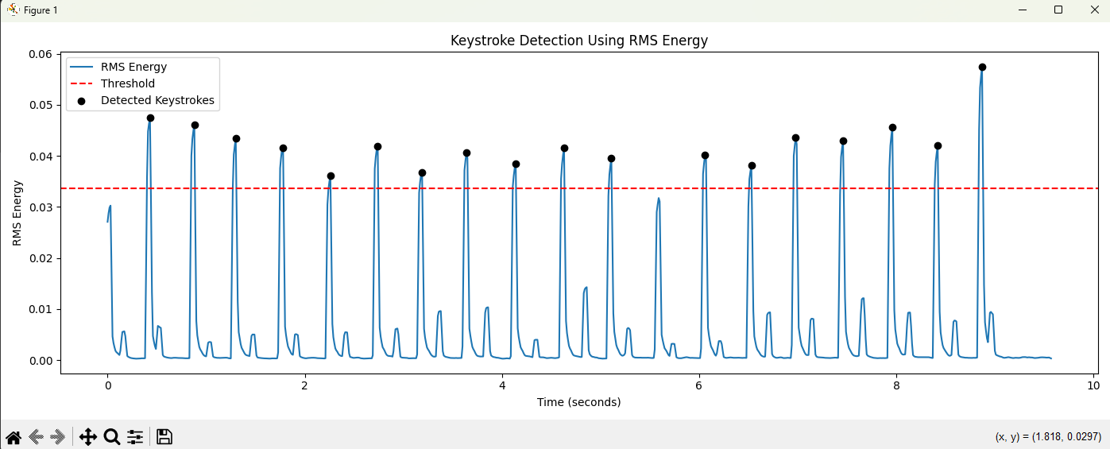
The above graphic is an example of the individual keystroke detection using RMS energy system at work.
3.3 Segmentation Quality Controls
Segmentation quality directly determines feature (MFCC) [2] [6] quality, the projects treat finding peaks and extracting valid keystrokes as separate concerns. A set of practical controls were used to verify that extracted keystroke windows were isolated keystrokes rather than background transients or misaligned windows. First, segmentation recall was monitored using expected versus extracted counts on repeated presses, large deviations were treated as indicators of either missed detections or overly sensitive thresholds which admitted extra peaks. This approach aligns with prior work showing that attack reliability is sensitive to the capture setup and environmental conditions [1] [4] [28] .
Secondly, waveform level diagnostics were used to detect obvious junk windows and confirm that the extracted segment captured the transient in the intended temporal position. In live testing as well as offline testing, statistics such as RMS energy, peak amplitude, crest factor, and peak position ratio were printed for the selected tap windows to catch cases where a window was dominated by silence, clipping, or non-keystroke impulses. This debugging information was treated as part of the segmentation quality gate rather than assuming all extracted keystroke windows were valid, the pipeline continuously checked whether window content matches the expected single transient + short decay structure.
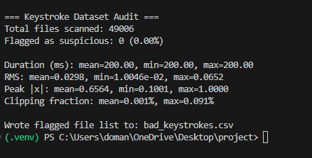
This keystroke audit is an example of debugging that was used and executed across my offline database which verified fixed window duration consistency, RMS energy and peak amplitude distributions as well as calculating clipping.
Thirdly, clipping was explicitly quantified rather than assumed from large peaks. Keystrokes, which are intuitively impulsive events, can legitimately produce large peak values, so I used a clipping metric based on proportion of samples exceeding a high absolute-amplitude threshold. This separated high peak from saturation, and the resulting clipping rate was extremely low in the extracted dataset. Further visual inspection was conducted to manually spot-check any discrepancies and confirm that we are extracting windows of clean, isolated keystrokes.
3.4 Sentence Mode Tuning
Moving on from single letter testing to typing short sentences introduced a different operation regime, keystrokes occur faster, inter-key timing becomes less uniform, and press intensity varies more than in repeated press sessions. In practice, this caused at least one word per sentence to have an incorrect length because one or more keystrokes were not detected which then hurts decoding. This gap between controlled offline performance and live usability is consistent with the broader challenge of making acoustic side channel inference under realistic interaction patterns difficult to make operational [1] [4] [24] .
To improve recall under natural typing, sentence mode uses more permissive segmentation settings compared to single letter and word modes. Detection sensitivity is increased by adjusting the RMS threshold and the debounce interval is reduced to avoid suppressing legitimate keystrokes typed in quick succession. These tunings aim to capture the correct number of taps over strict rejection of borderline events, because preserving word structure in the sentence mode is more important than perfect per tap precision. The trade off is that overly permissive settings can allow false positives from non-keystroke transients, which makes the system far less robust in a noisy environment due to false positives. [22] [1] [4] .
Finally, the sentence mode benefits from the introduction of the spacebar label. This introduction gives the system a robust boundary token for splitting continuous keystrokes into their individual words prior to decoding. In the live dataset, the spacebar was by far the most accurate and acoustically separable individual keystroke compared to all other classes, which makes sense acoustically due to the size of the actual key [1] [4] [22] [24] [28] .

4. Feature Extraction
4.1 MFCC Pipeline
Each extracted keystroke window is converted into a fixed-length feature vector using Mel-Frequency Cepstral Coefficients (MFCCS) [2] [6] . MFCCs are computed per-window using a Short-Time Fourier Transform (STFT) front-end and a Mel-scaled filter bank, producing compact descriptions of the spectral envelope of an acoustic event. In this project, 20 MFCC coefficients are extracted per frame using n_fft = 1024 and hop length of 256, consistent across both live and offline datasets. The first and second order temporal derivatives are computed to capture short term spectral dynamics during a keystroke transient and decay.
To produce a fixed-dimensional representation suitable for classical machine learning, the MFCC and time series are summarized by their mean and standard deviation over time. Concatenating mean and standard deviation for each of the 60 coefficient streams results in a 120-dimensional feature vector per keystroke. This aggregation reduces sensitivity prior to minor timing jitter within the window while retaining information about average spectral shape and variability. The implementation follows the MFCC computation provided by the librosa library [3] and uses consistent parameterization across training and interference [6] .

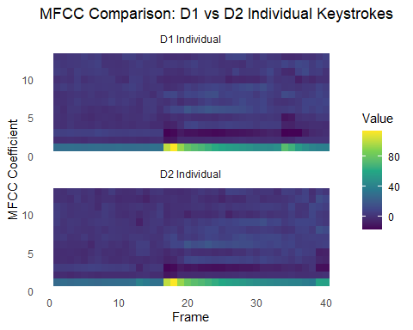
The above visualization was created in R Studio. ReadWave() [14] function is used for importing both files, while melfcc() extracts 13 MFCC coefficients from each one. Because two recordings may contain slightly different numbers of frames, min() is used to find the shorter frame length and both matrices are trimmed to match. Expand.grid() and as.vector() then reshape the MFCC matrices into data frames that can be plotted with ggplot2 [17] [18] . Finally, geom_tile() creates the heat maps and facet_wrap() function places the two samples into separate panels for direct comparison.[19] [20]
The result is a comparison of two separate heat maps for two clean samples. The academic benefit of analyzing this data is to simply see how it looks, MFCCs are not naturally interpretable to humans so visualizing them in a meaningful way is difficult, but in this case heat maps are an effective way to visualize the type of data that the machine learning model is in taking [7] . Notably even if we notice similarities between recordings, that doesn’t mean the model will behave in the way we think, this is just a visual representation of the data that the machine learning model will intake, however there is no way to see the true data the model is taking in a way that is interpretable.

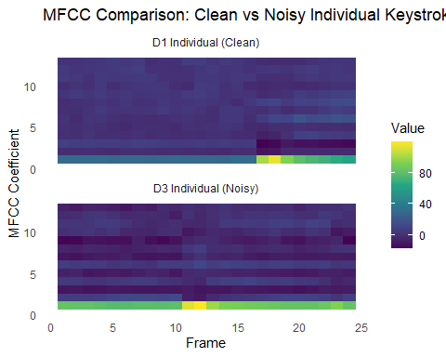
Although having mentioned that we cannot necessarily predict how a model will behave one way or another by visually assessing the MFCC heatmaps, in this case, we can see the wild differences between a clean and noisy individual keystroke sample [7]. Looking at a clean versus noisy sample, we can take an academic guess, that the noisy sample will not be seen as the same as the clean sample to the model, the point of not being able to predict the models behavior based on these visuals, is more relevant to the clean versus clean example, since there is still frame level variation in each sample, we cannot visually assess and predict that the model will see two MFCC features as the same even if they visually look identical due to frame level variability, however for wild differences between heatmaps, we can assess that the model will not see them as the same.
4.2 Rationale
MFCCs were chosen as my feature for classifying individual keystrokes because they offer a practical balance between separability, interpretability and computational efficiency. In speech and audio processing, MFCCs are widely used to represent timbral characteristics by approximating the human auditory frequency scale, and they have proven effective in modelling short acoustic events where spectral envelope is informative [2] [6] . Within the context of keystrokes, the mechanical impact and resonance of each key can create subtle but repeatable differences in spectral profile, which provide a compact way to capture these differences without requiring large models of heavy GPU resources [1] [4] [5] [23] [24] .
A further motivation for MFCCs in this project is that they are suitable for a lightweight classifier such as a Support Vector Machine (SVM) [25] . By converting each keystroke window into a single fixed length vector, MFCC statistics allow efficient training and inference [26] , enabling rapid iteration during live demonstration deployment. This fits the project’s constraints of reproducibility and minimal dependencies, while still producing strong offline and live classification performance under leakage-safe evaluation.
4.3 Distribution Shift
A recurring challenge in this project was the distribution shift between offline dataset which is being used for defensible evaluation and the data observed during live demonstration. The offline classifiers were able to achieve incredibly high performance when trained and evaluated under session safe splitting, however live predictions initially collapsed. The primary cause was not the MFCC representation itself, but the mismatch between how keystroke windows were extracted offline versus live. Small differences in event timing, window centering, sample rate of the microphone, or inclusion of non-keystroke transients can materially change the MFCC statistics and move live samples outside the feature distribution seen during training.
The issue was addressed by prioritizing segmentation alignment and by maintaining a separate live dataset versus offline. An entire new database of datasets was collected using the same recording pipeline and extraction logic currently being deployed in the demo. This reduced mismatch between training and inference distributions and improved stability. However, the project notes that broader sources of distribution shift remain, including microphone placement, gain or automatic processing in the capture chain, environmental noise and differences in users typing behavior all continue to change the model’s accuracy. These factors are well recognized in previous work on acoustic side channel attack reliability and represent current key limitations for generalization beyond controlled conditions [1] [4] [28] .

- Machine Learning Model

  - Model of Choice
This project uses a Support Vector Machine (SVM) model [25] [26] with an RBF kernel as the primary classifier per-keystroke prediction. The choice of SVM reflects the project’s constraints, it provides a strong classical baseline for medium-dimensional feature vectors, trains reliably on the CPU, and does not require deep learning frameworks or GPU acceleration. The RBF kernel is well-suited to the capturing of non-linear class boundaries produced in MFCC-derived feature space [2] [6] , where subtle spectral differences between keys may not be linearly separable. The theoretical basis for SVMs and margin-based classification is well established and the model choice is therefore both practical and academically grounded [1] [4] [24] .
In addition to the classifier itself, the model selection was influenced by deployment goals, the final system must operate in a live demo setting with minimal runtime. SVM inference is lightweight once the scalar and model are trained, and the entire model can be stored and reloaded using standard serialization. This makes it the appropriate choice of model for rapid iteration during development and for integration into my streamlit demo application.
  - Training Pipeline
Training is performed on the extracted per-keystroke dataset, where each sample corresponds to one windowed keystroke recording and a corresponding A-Z+SPACE label. The pipeline begins by loading all .WAV files, extracting MFCC-based features for each sample, and assembling a feature matrix X and label vector Y. Before classification, features are standardized using StandardScalar, which is fit on the training set only and then applied to both training and evaluation sets. This ensures that feature scaling does not leak information from the test set into the training process and improves SVM optimization stability considerably [9] .

Model performance is evaluated using the standard classification metrics and confusion matrices [8] . Accuracy provides a high-level summary while per-class precision [9] , recall [10] , and F1 score [11] highlight letter-specific weaknesses and consistent confusions. Confusion matrices [8] are particularly useful in this domain because errors are not always uniform, specific letter pairs exhibit repeated confusion patterns that are later exploited in word and sentence-level deciding. The evaluation metrics report follows scikit-learn’s definitions and implementations [10] .

For the live-current system, the project additionally implements a stable holdout evaluation split stored on disk so that repeated training reports on a consistent held-out set. This avoids reporting improvements that are simply artefacts of changing the test set between runs and provides a comparable baseline for tracking progress over time.
  - Leakage Control
A key methodological risk in acoustic keystroke classification is data leakage caused by overly similar samples appearing in both training and test sets. In this project, each recording session contains multiple keystrokes produced under nearly identical conditions such as same keystroke, same mic position and same background environmental factors such as desk vibration. If keystrokes derived from the same session are randomly split across training and testing, the model can achieve unrealistically high performance by effectively learning session specific acoustic details rather than generalizable keystroke characteristics. This issue has also been highlighted in prior keyboard acoustic work and is especially relevant when segmentation produces many near-duplicate windows from a single recording [1] [4] .
To address this, the project enforces session-aware splitting by treating the original recording session ID as a grouping variable. All keystrokes extracted from a given session are assigned the same group identifier and train/test splitting is performed at the group level so that the entire sessions are held out together. This produces a more defensible estimate of generalization to unseen sessions recorded under the same controlled setup. The same principle is maintained in the live-current dataset via consistent filename-based session identifiers, enabling stable evaluation and reducing the risk of inflated metrics during adaptive retraining.
Finally, leakage control is supported by the learning-curve style validation in which the model performance increases as more groups are added to training and caps as expected, which provides additional evidence that accuracy is not solely driven by accidental memorization of near-identical samples [26] [27].

- Offline Evaluation

  - Metrics
Offline metrics were evaluated using standard multi-class classification metrics. Overall accuracy is reported as a high-level measure of correct predictions across all keys, while class-specific, precision, recall [10] and F1-score [11] are used to quantify performance per letter and to identify systematic weaknesses. Precision reflects the proportion of predicted instances of a letter that were correct, recall reflects the proportion of true instances recovered, and F1-score provides a balanced mean summary of both precision and recall. Confusion matrices are additionally reported because errors in keystroke classification are typically structured, certain letter pairs exhibit consistent confusion patterns that are not visible from accuracy alone. All metrics and confusion matrices were computed using scikit-learn’s definitions and implementations [9]

  - Experimental Protocol
A primary requirement for defensible offline evaluation is avoiding leakage between training and testing when multiple samples originate from the same recording session. In this project, each source recording contains repeated presses of a single key under constant setup conditions, therefore, keystrokes extracted from the same session are highly correlated in terms of acoustic profiles due to same session, same mic placement and same environmental factors such as desk vibrations. To prevent inflated results caused by near-duplicate samples across splits, evaluation is conducted using session-aware grouping in which all keystrokes derived from the same original session are assigned a shared group identifier and are held out together during the train/test splitting. This provides a more realistic measure of generalization to unseen sessions recorded under the same controlled setup.
The offline evaluation uses a fixed split strategy, a held-out test set is reserved at the group/session level and used only for final reporting, while training data is scaled using StandardScalar fit on the training partition only. The model is trained on MFCC-based feature vectors and model fitting do not incorporate information from the test set [9] .
To further validate that performance reflects learning rather than accidental overlap, a learning-curve style experiment is used, model training is repeated with increasing amounts of training data while keeping the same held-out test set. The expected behavior is low performance at small training sizes with rapid improvements with more data and an eventual plateau, providing evidence that the classifier benefits from additional independent sessions rather than memorizing potential near-identical samples [26] [27] .
  - Results
Using the leakage-safe and session-aware evaluation protocol, the offline classifier achieved 98% accuracy on the held-out set. The learning-curve experiment showed the expected improvement as additional datasets were included in training, following diminishing returns when we reach over 1600 samples, this behavior supports that the model was not benefiting primarily from dataset leakage, and that performance increases were driven by exposure to a wider variety of independent sessions [26] [27] .
As shown in the results figures below, overall accuracy was really high reaching 97.6% and across all letters we were in and around that percentage of accuracy, this seems like the system would perform incredibly well however the datasets for the offline evaluation were recorded using an audio recording software called Audacity, which has parameters and settings that are preset and automatically configured which are not easily adjustable, this meant that when I began live demonstration implementation, the Virtual Studio Code environment and Audacity could effectively never have the same parameters and thus the MFCC features of data recorded using the Audacity software versus live dataset collection through a VSC terminal would never be aligned and therefore this data is not usable in a real demo environment. This is something I will explain in far greater detail when discussing the live demo implementation. What is noteworthy here is that the offline datasets are not applicable with live demonstrations and are merely beneficial for academic conclusions and essentially proving that the project is feasible and that individual keystrokes on the keyboard do indeed produce separable acoustic features however don’t provide actual practical implementations of an acoustic side channel classification system.
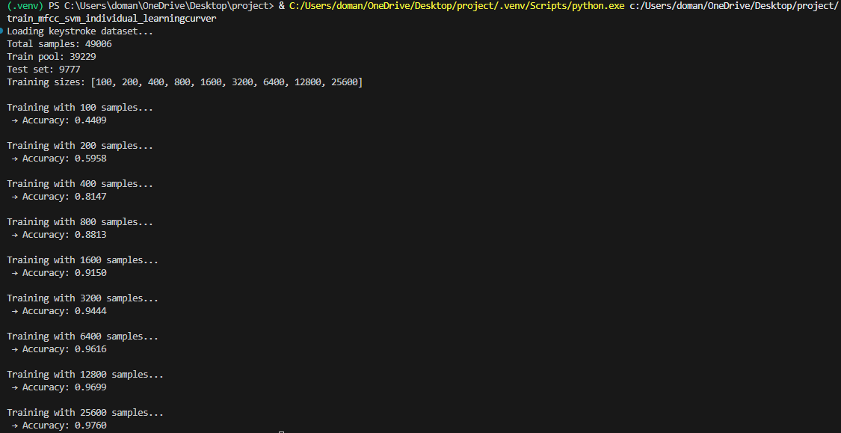
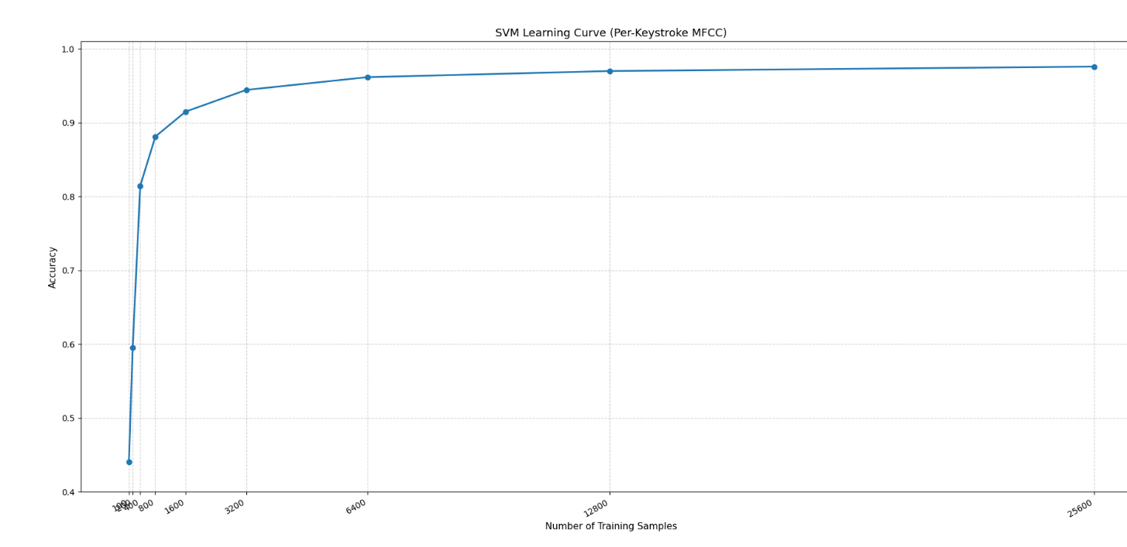

  - Interpretation
The offline results indicate that keystroke classification from acoustic features is feasible under controlled conditions and that MFCC plus SVM provides a strong baseline when combined with careful segmentation and leakage-safe evaluation. However, the distribution of errors suggests that keystroke acoustics are not equally separable for all keys. Persistent confusions shown later in the live demonstration implementation highlight a combination of physical and operational factors, including proximity of keys on the keyboard, similarly in mechanical resonance, and minor variation in typing force across sessions. Prior work similarly highlights that keyboard type, microphone placement and room acoustics strongly affect separability, which is consistent with the observation that performance is highest when these factors are controlled [1] [4] [28] .
A key takeaway from the offline evaluation is that the high accuracy alone is insufficient to claim a robust attack without defensible splitting. Session-level leakage can produce an artificially high and inflated set of results in this domain, so the session-aware grouping protocol is essential for credible reporting. Finally, offline performance does not fully predict live performance, because live inference introduces additional sources of variation including timing misalignment, background transients and capturing chain differences that can shift the feature distribution. For this reason, the later stages of the project focus on segmentation alignment and word/sentence decoding to improve end-to-end usability beyond per-keystroke accuracy [1] [4] [24] .

- Live System and Demo

  - Real-Time Pipeline
To demonstrate feasibility beyond offline evaluation, a separate, real-time pipeline was implemented to capture audio, segment keystrokes, extract MFCC [2] [6] features, classify the keystroke and decode the textual input. Audio is recorded from the input device and processed immediately after capture. Continuous recordings are segmented into candidate keystroke windows using lightweight energy-based detection, and fixed-length waveform segments are extracted for each detected event. Each subsequent extracted window is then converted into MFCC-based features and standardized using the scalar fitted during training, before being classified by an SVM model [25] into a key label.
For practical robustness, the demo supports multiple interaction modes including the single-letter prediction via majority voting over repeated presses, the fixed-length word decoding using a dictionary list and a sentence mode where the spacebar label provides word boundaries for chunking and per-word decoding. These modes were designed to reduce the impact of occasional per-tap errors on end-to-end usability while maintaining a lightweight, reproducible system.
  - Key Failures
A key finding from live testing is that high offline accuracy does not automatically translate to stable real-time performance. Early live runs exhibited failure modes such as biased outputs (repeated predictions of one class), unstable predictions and unreliable word decoding. The dominant cause was the distribution shift between offline and live keystroke windows, small differences in timing, window centering or inclusion of non-keystroke transients that changed MFCC statistics, pushing live samples outside the training distribution [1] [2] [4] [6] .

In addition, energy-based peak detection is sensitive to real-world transients. Background impulses (desk vibrations and handling noise) can trigger false positives, while fast typing can lead to missed detections if debounce settings are too strict. These sensitives are consistent with prior acoustic keyboard work [1] [4] [28] emphasizing that microphone placement, room acoustic, keyboard type and typing behavior strongly affect performance. Realistic capture channels also matter acoustic leakage can be observed in VoIP scenarios, motivating robustness beyond ideal recordings. [24]

  - Improvements Implemented

To stabilize the live system, development adopted a DSP-first approach which entailed prioritizing segmentation alignment and window quality before relying on classification and decoding. First, the system used onset-anchored window extraction to improve temporal consistency. Rather than solely centering on the RMS peak which can lag the physical impact, the pipeline estimates the onset and refines the impact time before extracting a fixed window. This reduces timing jitter and improves consistency between offline and live samples which is critical because feature extraction depends heavily on alignment.

Second, demo-oriented quality handling was introduced to improve usability. Instead of frequently hard-rejecting windows which leads to repeated no output events, the pipeline favors cleaner windows while still producing predictions when the user provides reasonable keystrokes. This design choice reflects the practical aim of producing a consistent demonstration under time and hardware constraints [22] .

Thirdly, the project implemented word and sentence-level decoding to reduce the effect of isolated per-tap errors. By applying and using a dictionary list as well as beam-style sequence decoding which will be explained in greater detail in the following sections, the system can recover plausible words from noisy per-letter predictions. Spacebar label was added as an explicit class separation method to provide reliable word boundary detection for sentence mode.

After these improvements were implemented, across ten runs, we were able to, using the single letter guessing mode, guess each letter in the alphabet at least once in our majority prediction except for three broken classes of “M”, “N” and “L”.

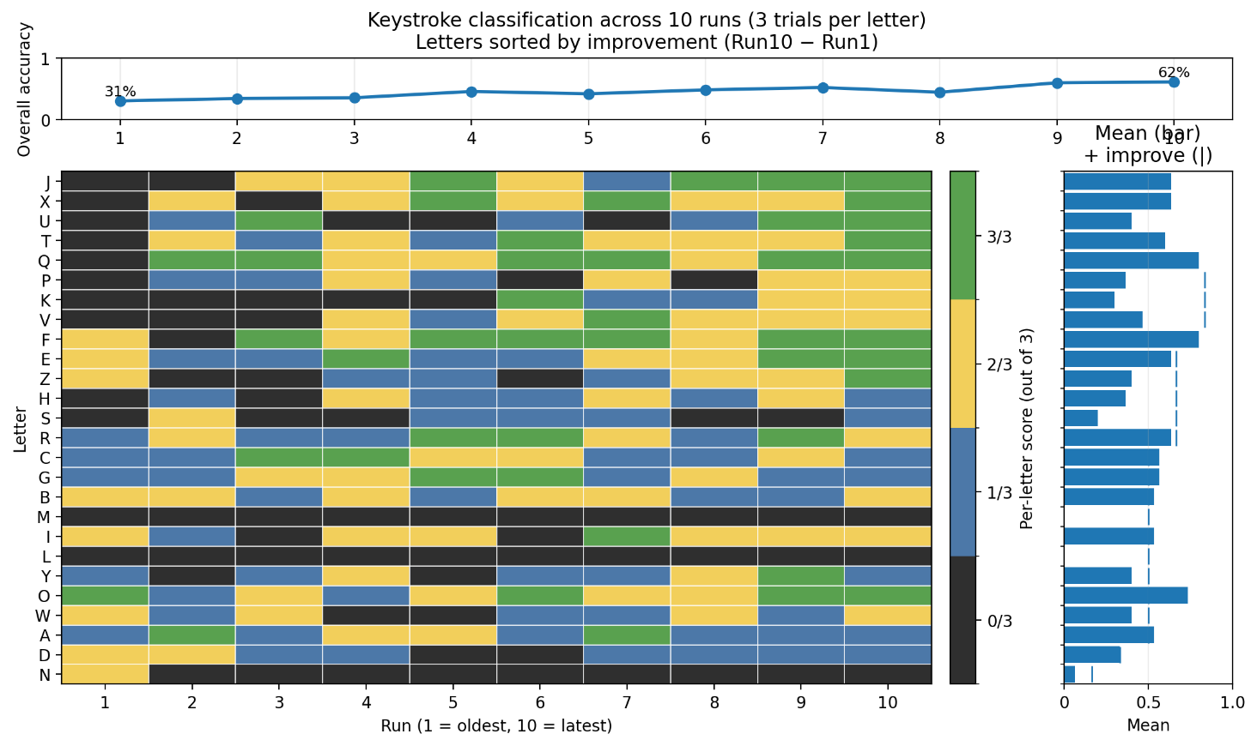

7.4 Adaptive Live Training

To improve realism under natural typing, the system implemented adaptive live training on separate live-current database that is explicitly kept independent of the offline defensible evaluation database. When a prediction is incorrect, the user can provide a true label, and the corresponding tap(s) are appended to the live-current database. After a configurable number of corrections, I have it set to thirty, the system retrains the SVM on the entire live-current database including the newly acquired corrections and prints an updated evaluation report using a stable holdout split. This provides visible and repeatable evidence that the system can incorporate new samples from the current capture setup without contaminating the offline evaluation pipeline.

This adaptive mechanism is presented as a demonstration capability rather than a defensible scientific evaluation, the goal is to show that performance can be improved interactively under consistent conditions, and to highlight a security relevant point that if an attacker can collect labelled audio from the target setup, model performance can improve over time [1] [4] [22] .

Adaptive live training proved to be very successful, and as shown in the figure below, you can see from my raw log collection of running the system running, we gradually improved and after ten runs we were able to hit 61.5% accuracy, having predicted every letter in the alphabet except “L”, “M” and “N” which after much work, these three classes were consistently receiving no accuracy, after much debugging and investigating, I could not improve these broken classes, and as I will discuss in the following section, heavy focus was put on the decoding of words and sentences in order to try append the three classes that refused to improve in accuracy.
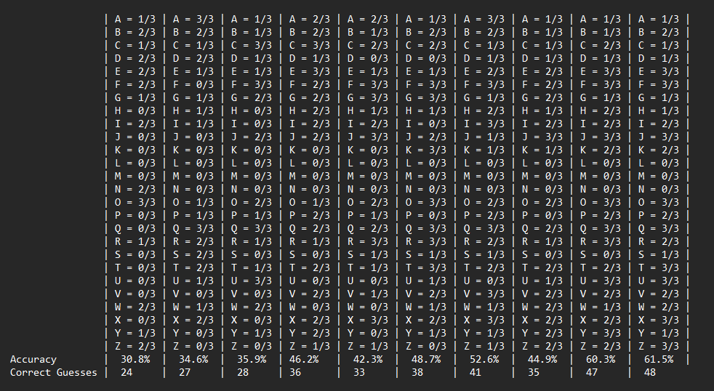

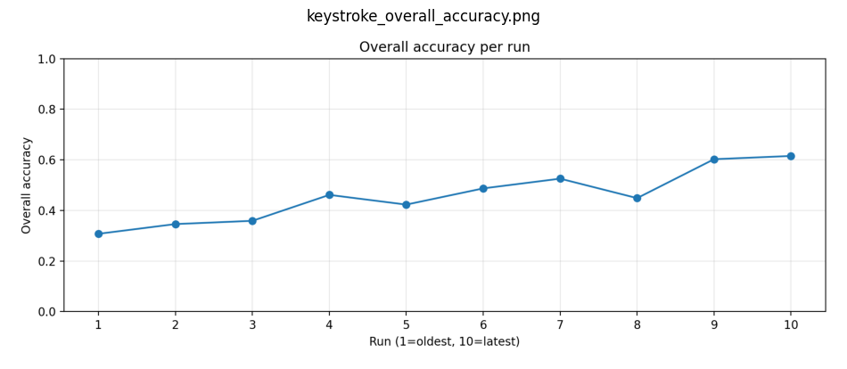

Another visual representation that’s much nicer than the raw log to demonstrate the live adaptive training working shows the gradual improvements recorded by the system, again reiterating that the adaptive live training is not only functional, but providing academically sound and proven improvements in the systems performance regarding actual live demonstration testing.

At this point, I had by that tenth run, correctly classified 16/26 letters in the individual keystroke guessing mode, and at least 1 of 3 guesses for 7 further letters, leaving only the three broken classes with no predictions at all, this put me in a position where I was happy to move on to word and sentence level decoding, which I will discuss in greater detail in the following section and subsequent sub-sections.
- Word and Sentence Decoding

  - Fixed-Length Word Decoding
Although per-keystroke classification can achieve strong offline performance, real-time usage introduces occasional letter errors that compound when reconstructing text. To reduce the impact of isolated misclassifications, the live system implements fixed-length word decoding that operates on a sequence of keystroke predictions rather than treating each prediction independently. For each keystroke position, the classifier outputs decision scores over the alphabet, these scores are converted into a probability-like distribution using a softmax transformation with a tunable temperature parameter. Higher temperature values flatten the distribution and allow alternative letters to remain competitive when the classifier is uncertain, which is beneficial in live settings where timing and capture conditions can shift feature distributions.
Decoding is performed using a beam-style sequence search. Instead of committing to the single top 1 letter predictions, the decoder keeps multiple high scoring combinations of letters and expands them across positions using the top predicted letters. This prevents early mistakes from permanently eliminating the true word when the correct letter appears at the second or third best option. The resulting candidate sequences are then filtered against a dictionary wordlist, and the best scoring valid word is selected. This dictionary constraint provides an effective correction layer, allowing plausible words to be recovered even when one or more letters are misclassified
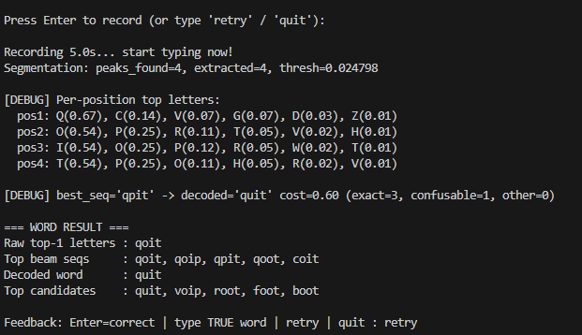
This figure shows an example of the word decoding system at work, the beam sequence returns options “qoit”, “qoip”, “qpit”, “qoot” and “coit”, and from those five beam sequence selected words, the model knows that from “qoit” we are just one letter away from snapping to a dictionary word, therefore we make that prediction and snap to a real dictionary word. There is also a list of top candidates where the system scores most likely words trying to make as little changes as possible to the input text.
  - Confusion-Aware Substitutions
In practice, keystroke misclassifications are not typically random, certain letter pairs are more commonly repeatedly confused due to proximity to each other on the keyboard and consequent similar acoustic signatures. To exploit this structure, I made note of my most misclassified pairs of letters and implemented a confusion-aware substitution table to use during decoding. A confusion cost table is derived from rigorous live testing, denoting which misclassifications are most common and note those as low cost versus unlikely misclassifications which should be high cost. During dictionary matching, candidate words are scored not only by acoustic likelihood, but also by the total substitution cost required to transform a sequence into a candidate word.
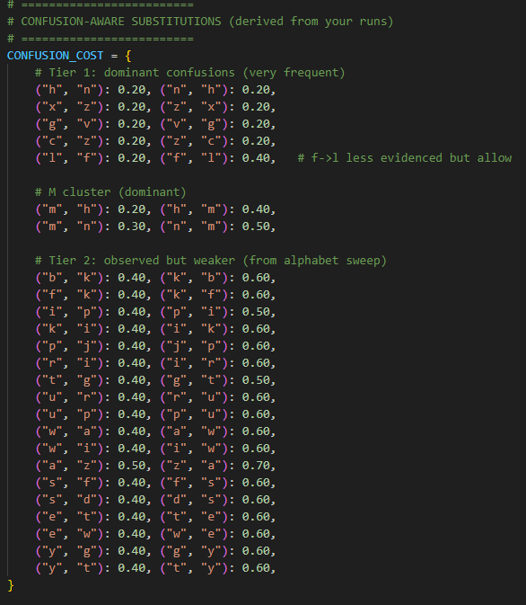
To put simply, we allow a total of 1.0 cost to change our top-beam sequence candidate into a dictionary word, using this cost table, our model knows that if the intended word typed by a user is say “moon” and we have returned “mooh” from our top-beam sequence candidate list, then the system is aware that “h” and “n” are a very frequently confused pair of letters due to acoustic similarities and proximity on the keyboard, therefore the system knows that the cost to change “h” to “n” is only 0.2 which is well under the allowed 1.0 cost to make a change, and going through the dictionary list, the system will realize we can change “h” to “n” in order to snap to a dictionary word, and since the cost of the substitution is well below our allowed substitution, it will make that change and snap to the correct word.
This approach ensures that the decoder preferentially selects the dictionary corrections that correspond to observed confusion patterns. The system also discourages arbitrarily reshuffling the word to snap to a dictionary word preserving the intended rule that decoding should not radically change a word unless the evidence such as provided by the confusion-aware substitution cost table, while still enabling targeted corrections where the model’s confusions are well characterized.
  - Sentence Mode and Spacebar Integration
Sentence mode extends word decoding to continuous typing by treating the keystroke stream as a sequence of letters and the space events. In this mode, a single recording is segmented into keystroke windows, each window is classified, and predicted space events are used to split the sequence of text into word chunks. Each chunk is then decoded using the same dictionary-constrained beam approach as described in the previous section. This design allows for end-to-end sentence reconstruction using the same lightweight classifier, without requiring a full language model.
A critical enabling step was the integration of the spacebar label, as an explicit class in training and prediction. Spacebar events are acoustically distinct and by far my data shows that it is the easiest label to classify, this makes it a very reliable boundary token for chunking continuous input into words. This boundary information is essential for sentence decoding because word-level dictionary constraints require correct word segmentation, without space detection, even a small number of missed or inserted characters can shift boundaries and cause decoding failures. Sentence mode therefore combines higher-recall segmentation tuning, explicit space classification and dictionary-based decoding to produce plausible sentence output under realistic typing conditions.
Sentence mode operates under a more challenging regime than fixed-length word entry because neutral typing introduces faster inter-key timing, variable press force and more frequent boundary events. As a result, sentence decoding is primarily limited by segmentation recall, a single missed keystroke changes word length and shifts downstream character positions, causing major decoding errors. To address this, the system uses sentence-tuned segmentation settings that are intentionally more permissive than the word or single letter modes. This involves lowering the detection sensitivity threshold and reducing the debounce interval so that rapidly typed keystrokes are less likely to be suppressed as duplicates. While these settings increase the risk of occasional false positives from non-keystroke transients, sentence mode compensates by applying stronger downstream constraints to recover plausible words and sentences even when individual keystrokes are noisy.
Unfortunately, with time constraints and deadlines, the sentence-level decoding remains the least mature component of the entire system and is not operationally reliable under natural typing. In contrast to the single-letter and fixed-length word modes, sentence input amplifies the upstream errors including missed detections, false positives or small timing misalignment in segmentation which can propagate into incorrect word lengths and boundary shifts, which in turn causes failures during decoding. For this reason, sentence mode is presented as a forward-looking proof of concept rather than a fully validated capability. Its inclusion in the project is meant to demonstrate how the existing per-keystroke classifier can be integrated with boundary detection using the spacebar label and language-level constraints to move from isolated keystroke inference toward end-to-end text recovery. The current implementation therefore serves as a sort of scaffolding for future work, where improvements in segmentation robustness and additional training data could make continuous sentence reconstruction practical.

- GUI Implementation
A localhost demonstration interface was implemented using Streamlit [29] to provide a clean, reproducible front-end for the live keystroke pipeline. The application was intentionally designed as a thin wrapper over the existing system rather than a separate prototype. It imports to the core pipeline module kbd_live_pipeline and reuses the same segmentation, MFCC [2] [6] feature extraction and SVM [26] inference logic used throughout the project. Model artefacts such as the trained live-current SVM and the fitted scalar are loaded from disk and cached to avoid repeated reloads during interaction, creating a responsive application to use during demonstration. The user workflow is streamlined, the operator selects a mode, adjusts decoding controls if required using a simple slider, triggers capture via a simple “Record & Decode” button, and receives both segmentation diagnostics including number of extracted taps, threshold and decoded outputs to the screen. This interface improves usability and presentation quality by reducing command-line interaction.
The GUI shows three modes of operation, the single-letter, fixed-length word as well as sentence mode, each of which places different demands on segmentation recall and downstream decoding. Consequently, different parameter defaults are appropriate for each mode.
For the single letter mode, it is designed to demonstrate stable per-keystroke classification. The user presses the same keystroke multiple times (they choose how many presses and recording length) before the system predicts each tap independently and prints a majority vote. Since the objective is to validate letter-level discrimination rather than recover long text, the decoder should strongly trust the classifier’s top prediction. Appropriate configuration settings use a relatively lower decoding temperature and a small vote count to smooth occasional mis-segmentation or single-tap uncertainty.
Fixed length word mode demonstrates word recovery when the intended word length is known. This benefits from modestly increased exploration during decoding because a single per-keystroke error can invalidate the raw top 1 spelling. Recommended settings therefore use a moderate decoding temperature and a beam search configuration that retains multiple hypotheses, beam width and top K per position should be high enough that the correct letter is unlikely to be pruned early when it is ranked second or third at one position. A dictionary list is then applied to select the best valid word consistent with the acoustic evidence.
Sentence mode as mentioned remains the most challenging and least reliable mode, as natural typing introduces variable timing, inconsistent force and frequent boundary events. In this setting, segmentation recall becomes the dominant failure mode ergo a single missed keystroke changes an entire words length and can cause cascading errors during reconstruction of words. Sentence mode therefore requires much looser segmentation parameters and larger beam settings to increase robustness to decrease uncertainty. Debounce is also reduced relative to single-letter mode to avoid suppressing legitimate keystrokes typed in quick succession and the expense of admitting occasional false positives.
The interface, as mentioned, provides a small set of advanced controls to tune the trade off between trusting the model and exploring alternatives. The following are those settings explained in some detail.
Decoder temperature governs how peaked the probability distribution is when converting classifier detection scores into decoding probabilities. Lower values force the decoder to commit more strongly to its initial top letter guesses while higher values flatten probabilities and encourage the system to seek alternatives that may be required for recovering a piece of text under live uncertainty.
Beam width sets how many partial sequences are retained during sequence decoding. Larger beam widths reduce the risk of discarding the correct theorized word early but increase computational time.
Top-K per position limits expansions at each character position to the predicted top letters. Higher values reduce early pruning errors but increase runtime.
Sentence debounce controls the minimum enforced separation between detected keystrokes. Lower values improve recall for faster typing but can increase false detections from non-keystroke transients. Higher values reduce false positives but can miss legitimate keystrokes when typing speed is increased.

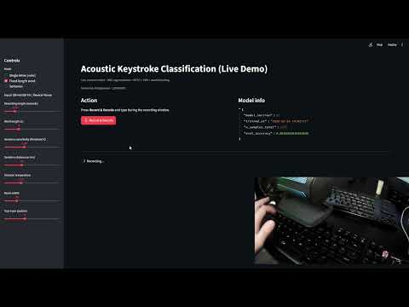

Attached is a video demonstration of the project working as described, single-letter, fixed-length word and sentence mode all on display as well as a brief look at the application that was built. The reason for including this video demonstration is due to the fact that there is a non-zero chance that a live demonstration in a different environment with different acoustic features of the room could cause instability in the model performance, therefore I thought it appropriate to attach this video as evidence that the system was functional prior to the live demo.

- Security Discussion

  - Threat Model and Realism

This project was framed within the threat model of an acoustic side-channel attack, where an adversary attempts to infer what a user has typed using nothing but the sound of the keystrokes produced from textual input by the operator [1] [4] . In the most direct scenario, the attacker would have to access microphone recordings of textual input in the same environment as the targeted keyboard. Acoustic side-channel attack threats are widely recognized as a legitimate class of security risk because they exploit unintended leakage rather than software defects [22] and leave little to no traceability of an attack occurring.

In realistic deployments, the attacker’s capability is constrained by factors such as microphone quality, distance to keyboard, background noise and device processing in the audio chain. Nevertheless, research demonstrates that keystroke acoustics can contain sufficient information for inference under favorable conditions and that modern approaches including deep learning can improve performance when large data and stable conditions are available [1] [4] [23] . A further realistic pathway is remote capture through communication channels, prior work has shown that audio captured during VoIP calls can leak keystroke information, supporting the plausibility of microphone-based inference even when a dedicated recording device is not physically located near the keyboard [24] .

Accordingly, this project positions its main claims conservatively. The demonstrated attack is feasible under controlled conditions with a known capture setup and illustrates how a practical end-to-end system can be constructed using consumer-grade microphones, lightweight signal processing and classical machine learning.

10.2 Sensitivity Analysis

A central security takeaway is that acoustic keystroke inference is highly sensitive to physical and operational conditions. Research and practical deployment of this project shows that performance was strongly affected by microphone placement relative to the keyboard, room acoustics and user typing behavior [1] [4] [28]. Small changes can shift the signal-to-noise ratio and alter the spectral profile of keystrokes, reducing the reliability of a model trained under a fixed setup such as the one being presented.

The project also observes sensitivity to segmentation alignment, particularly when moving from offline evaluation to live demonstration. Even when the classifier performs strongly offline under leakage-safe conditions, live performance can degrade sharply if keystroke windows are misaligned, if debounce settings suppress legitimate keystrokes that were simply rapidly typed or if non-keystroke transients are misidentified as legitimate keystroke transients. The sensitivity is security-relevant since it implies that a successful attack is not solely a matter of selecting a classifier but also depends on robust event detection and consistent, stable capture conditions.

Finally, practical realism is influenced by how much target-specific data an attacker can collect. If the threat actor can identify the keyboard being used and source it themselves, they could in theory follow the process outlined by this report to create their very own portable and lightweight acoustic side channel attack classification system.

10.3 Defenses

From a defensive perspective, results reinforce the fact that reducing acoustic leakage and disrupting an attacker’s signal pipeline can greatly affect the reliability of such an attack. One class of defenses targets the acoustic channels directly, such as increasing ambient noise, noise masking or using physical dampening which can reduce keystroke-to-background contrast and destabilize segmentation. Even moderate masking can cause missed detections or timing jitter that cascades into decoding failures.

A second class of defenses targets microphone capture and placement, increasing the distance between a keyboard and microphone, changing microphone orientation or physically blocking direct sound paths reduces capture consistency. Practical guidance on microphone placement highlights how geometry and reflections can influence captured audio, suggesting that small changes in setup can reduce exploitable signal quality [28] . In managed environments, policy-based controls such as restricting microphone permissions, disabling microphones when not needed or enforcing push-to-talk can reduce attacker access to audio streams and limit exposure, aligning with broader side channel mitigation principles [22] .

Finally, the existence of realistic capture routes motivates application-level awareness, users that are typing sensitive credentials while microphones are active can increase exposure and secure workflows should assume that physical side channels may exist even when software is uncompromised [24] .

- Limitations
This project demonstrates that acoustic inference is feasible under controlled conditions using a lightweight pipeline, but several limitations constrain the operational reliability of results.
First, the experimental setup is intentionally controlled, recordings were collected using a fixed microphone placement and a single purposely loud keyboard. As established in prior work, acoustic keystroke signatures are sensitive to microphone placement, room acoustics and keyboard type. Consequently, a model trained under one configuration will not generalize to different hardware and different environments [1] [4] [28] .
Secondly, the live system is fundamentally limited by segmentation robustness. RMS-based peak detection is lightweight and effective in quiet conditions; however, it is vulnerable to detecting non-keystroke transients and can miss keystrokes which are occurring during rapid or low-force typing. Small window misalignments can materially change the MFCC features extracted and reduce classifier stability, which explains the gap between offline and live performance.
Thirdly, whilst word and sentence-level decoding improve stability, it introduces dependance on external language resources. Dictionariy-constrained decoding cannot recover words that are absent from the dictionary list, and sentence mode amplifies segmentation errors where a single missed or inserted keystroke can change the word length and cause decoding failures. As implemented, sentence mode is therefore best viewed as a proof of concept demonstrating how keystroke classification can be integrated with boundary detection using the spacebar label rather than a fully operational transcription system [22] [24] .
Fourth, the adaptive live training mechanism improves demonstration realism, but it is not treated as a part of the defensible evaluation. Allowing user-corrected samples to be appended to the live-current dataset can bias performance toward the specific conditions used during the demo. This capability is included to show how an attacker could improve performance with additional labelled data from the target configuration, but it does not represent cross-device or cross-environment generalization [22] [27] .
Finally, the project does not attempt to defeat all practical barriers to real-world exploration. Robust operation under heavy background noise, across multiple users, multiple keyboard types, or over remote audio channels would likely require more advanced signal processing, stronger language modelling or larger-scale data collection than was feasible under the scope and time constraints of this project.
- Conclusion

In conclusion, the project investigated the feasibility of acoustic side channel keystroke inference using only consumer grade microphone recordings, lightweight machine learning and only open-source tools and methodologies. An end-to-end pipeline was designed and implemented to segment continuous audio into individual keystroke windows, extract MFCC features [2] and classify keystrokes using an SVM [25] . The work placed strong emphasis on defensible evaluation methodology, addressing the risk of inflated accuracy through session-aware leakage control and reporting results using standard classification metrics and confusion matrices [7] [8] [9] [10] [11] .

Beyond offline evaluation, the project implemented and refined a live demonstration system. Live testing revealed that segmentation timing and alignment are dominant practical bottlenecks where even a strong offline classifier can degrade in real time if extracted windows are misaligned or contain non-keystroke transients. To mitigate this, the project pipeline introduced onset-anchored window extraction and demo-oriented robustness features and extended the system with word-level decoding and a proof-of-concept sentence decoding mode. The addition of an explicit space class enabled reliable word boundary detection and supported multi-word reconstruction.

A local host GUI was built in streamlit [29] , to provide a clean interface for demonstration and parameter exploration, improving usability and allowing the system to be evaluated consistently across modes. Finally, the project contextualized its results within a security discussion, highlighting the feasibility and how it depends on capture conditions, how performance can improve when target-specific data such as keyboard type is available and what mitigation strategies can reduce acoustic leakage [22] [24] [27] [28] .

Overall, the project demonstrates that keystroke classification from acoustic signals is practical under controlled conditions using open-source tooling and classical machine learning, while also showing the challenges that can arise when moving from offline defensible benchmark evaluations to real-time live demonstration implementations of the system. The forementioned implemented system produces a reproducible foundation for future work on more robust segmentation, broader generalization across devices and environments as well as stronger language-level reconstruction for continuous typing [1] [4] [23] .

- References:
[1] Asonov, D. and Agrawal, R. (2004)
‘Keyboard acoustic emanations’, IBM Almaden Research Center.
Available at: https://web.eecs.umich.edu/~genkin/teaching/fall2019/EECS598-12_files/kbdacoustic.pdf
(Accessed: 10/03/2026).

[2] Logan, B. (2000)
‘Mel Frequency Cepstral Coefficients for Music Modelling’, Cambridge Research Laboratory, Compaq Computer Corporation, 23–25 October.
Available at: https://ismir2000.ismir.net/papers/logan_paper.pdf
(Accessed: 10/03/2026).

[3] Librosa development team (2025)
‘Glossary — librosa 0.11.0 documentation’, librosa documentation.
Available at: https://librosa.org/doc/0.11.0/glossary.html
(Accessed: 10/03/2026).

[4] Zhuang, L., Zhou, F. and Tygar, J.D. (2009)
‘Keyboard acoustic emanations revisited’, ACM Transactions on Information and System Security, 13(1).
Available at: https://people.eecs.berkeley.edu/~tygar/papers/Keyboard_Acoustic_Emanations_Revisited/TISSEC.pdf
(Accessed: 10/03/2026).

[5] Fessler, J. (2024)
‘Eng. 100: Music Signal Processing DSP Lecture 6 Lab 3’, University of Michigan.
Available at: https://web.eecs.umich.edu/~fessler/course/100/l/l06-lab3-spectrogram.pdf
(Accessed: 10/03/2026).
[6] librosa development team (2025)
‘librosa.feature.mfcc’, librosa documentation.
Available at: https://librosa.org/doc/main/generated/librosa.feature.mfcc.html
(Accessed: 10/03/2026).

[7] Olah, C. et al. (2018)
‘The Building Blocks of Interpretability’, Distill.
Available at: https://distill.pub/2018/building-blocks/
(Accessed: 10/03/2026).

[8] Scikit-learn developers (n.d.)
‘confusion_matrix’, scikit-learn documentation.
Available at: https://scikit-learn.org/stable/modules/generated/sklearn.metrics.confusion_matrix.html
(Accessed: 10/03/2026).

[9] scikit-learn developers (n.d.)
‘Metrics and scoring: quantifying the quality of predictions’, scikit-learn documentation.
Available at: https://scikit-learn.org/stable/modules/model_evaluation.html
(Accessed: 10/03/2026).

[10] scikit-learn developers (n.d.)
‘precision_recall_fscore_support’, scikit-learn documentation.
Available at: https://scikit-learn.org/stable/modules/generated/sklearn.metrics.precision_recall_fscore_support.html
(Accessed: 10/03/2026).

[11] scikit-learn developers (n.d.)
‘f1_score’, scikit-learn documentation.
Available at: https://scikit-learn.org/stable/modules/generated/sklearn.metrics.f1_score.html
(Accessed: 10/03/2026).

[12] Ligges, U. and Schnackenberg, S. (2025)
‘tuneR: Analysis of Music and Speech’, CRAN R package documentation.
Available at: https://cran.r-project.org/web/packages/tuneR/tuneR.pdf
(Accessed: 05/04/2026).
[13] Ligges, U. and Schnackenberg, S. (n.d.)
‘readWave: Reading Wave files’, tuneR documentation.
Available at: https://search.r-project.org/CRAN/refmans/tuneR/html/readWave.html
(Accessed: 05/04/2026).

[14] Sueur, J. (2025)
‘A very short introduction to sound analysis for those who want to do bioacoustics in R’, seewave vignette.
Available at: https://cran.r-project.org/web/packages/seewave/vignettes/seewave_analysis.pdf
(Accessed: 05/04/2026).

[15] Sueur, J., Aubin, T. and Simonis, C. (2025)
‘seewave: Sound Analysis and Synthesis’, CRAN R package documentation.
Available at: https://cran.r-project.org/web/packages/seewave/seewave.pdf
(Accessed: 06/04/2026).

[16] Wickham, H. et al. (2026)
‘ggplot2: Create Elegant Data Visualisations Using the Grammar of Graphics’, CRAN R package documentation.
Available at: https://cran.r-project.org/web/packages/ggplot2/ggplot2.pdf
(Accessed: 08/04/2026).

[17] Garnier, S. et al. (2024)
‘Introduction to the viridis color maps’, viridis vignette.
Available at: https://cran.r-project.org/web/packages/viridis/vignettes/intro-to-viridis.html
(Accessed: 09/04/2026).

[18] Garnier, S. (n.d.)
‘viridis: Colorblind-Friendly Color Maps for R’, viridis package page.
Available at: https://sjmgarnier.r-universe.dev/viridis
(Accessed: 09/04/2026).

[19] Posit Software, PBC (2026)
‘reticulate: Interface to Python’, CRAN R package documentation.
Available at: https://cran.r-project.org/web/packages/reticulate/reticulate.pdf
(Accessed: 10/04/2026).

[20] Posit Software, PBC (n.d.)
‘Import a Python module’, reticulate reference.
Available at: https://rstudio.github.io/reticulate/reference/import.html
(Accessed: 10/04/2026).

[21] Posit Software, PBC (2026)
‘Convert between Python and R objects’, reticulate documentation.
Available at: https://rdrr.io/cran/reticulate/man/r-py-conversion.html
(Accessed: 12/04/2026).

[22] National Institute of Standards and Technology (2020)
NIST SP 1800-21B: Side-Channel Attacks.
Available at: https://nvlpubs.nist.gov/nistpubs/SpecialPublications/NIST.SP.1800-21.pdf (Accessed: 17/11/2025).

[23] Harrison, J., Toreini, E. and Mehrnezhad, M. (2023)
‘Practical deep learning-based acoustic side-channel attack on keyboards’,
Available at: https://arxiv.org/pdf/2308.01074 (Accessed: 21/11/2025).
[24] Compagno, A., Lain, D., Tsudik, G. and Conti, M. (2017)
‘Don’t Skype & Type! Acoustic eavesdropping in VoIP calls’, arXiv preprint, arXiv:1609.09359.
Available at: https://arxiv.org/pdf/1609.09359 (Accessed: 30/11/2025).

[25] Cortes, C. and Vapnik, V. (1995)
‘Support-vector networks’, Machine Learning, 20(3), pp. 273–297.
Available at: https://web.engr.oregonstate.edu/~huanlian/teaching/ML/2018spring/extra/svn-1995.pdf Accessed: (02/12/2025).

[26] Hastie, T., Tibshirani, R. and Friedman, J. (2009)
The Elements of Statistical Learning: Data Mining, Inference, and Prediction. 2nd ed.
Available at: https://esl.hohoweiya.xyz/book/The%20Elements%20of%20Statistical%20Learning.pdf (Accessed: 02/12/2025).

[27] Althnian, A., AlSaeed, D., Al-Baity, H., Samha, A., Bin Dris, A., Alzakari, N., Abou Elwafa, A. and Kurdi, H. (2021)
‘Impact of dataset size on classification performance: An empirical evaluation in the medical domain’, Applied Sciences, 11(2), 796.
Available at: https://www.mdpi.com/2076-3417/11/2/796 (Accessed: 01/12/2025).

[28] Biamp Technical Support (2020)
Microphone placement – acoustic concepts.
Available at: https://support.biamp.com/General/Audio/Microphone_placement_-_acoustic_concepts (Accessed: 29/11/2025).

[29] Streamlit Developers (2026)
‘Streamlit documentation’ Streamlit Docs.
Available at: https://docs.streamlit.io/
Accessed (16/04/2026)

